1. 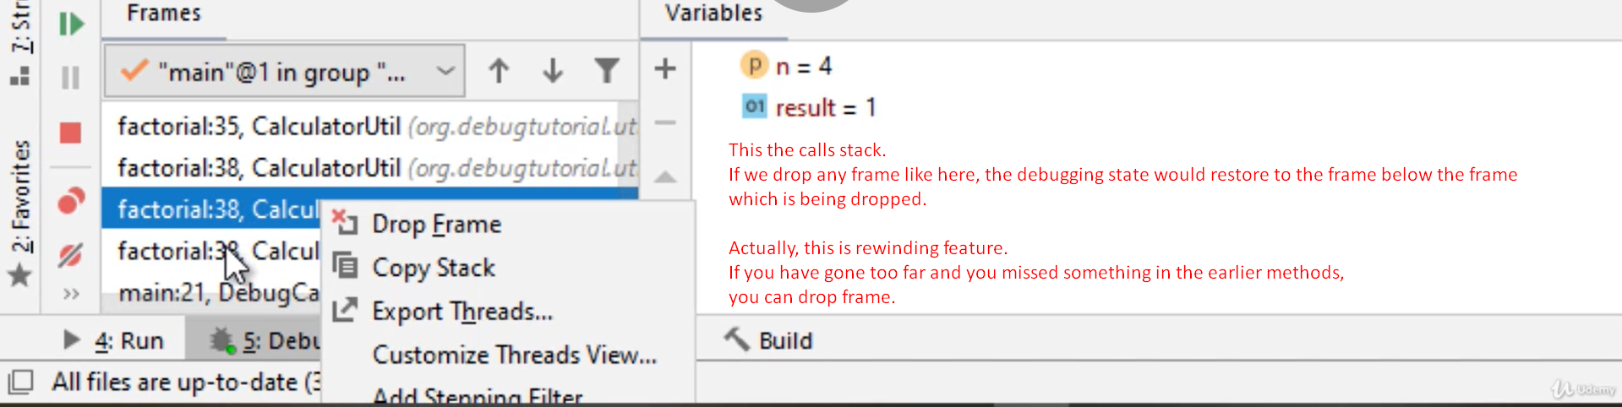
2. **NOTE**: The global variables’ value would not be reset as per the restored frame.